Contact Manager
Ideation Phase
Define the Problem Statements

Date | 07/03/2026
Team ID | 69a7d7903987a2df4043eaef
Project Name | Contact Manager
Maximum Marks | 2 Marks

Problem Statement

People often find it difficult to manage and organize their contacts because the information is stored in different places such as mobile phones, messaging apps, and notes. Most existing solutions focus mainly on mobile devices and do not provide an easy way to manage contacts on laptops or desktop systems. Therefore, a simple contact management system is needed to store, organize, and quickly retrieve contact details in one place.

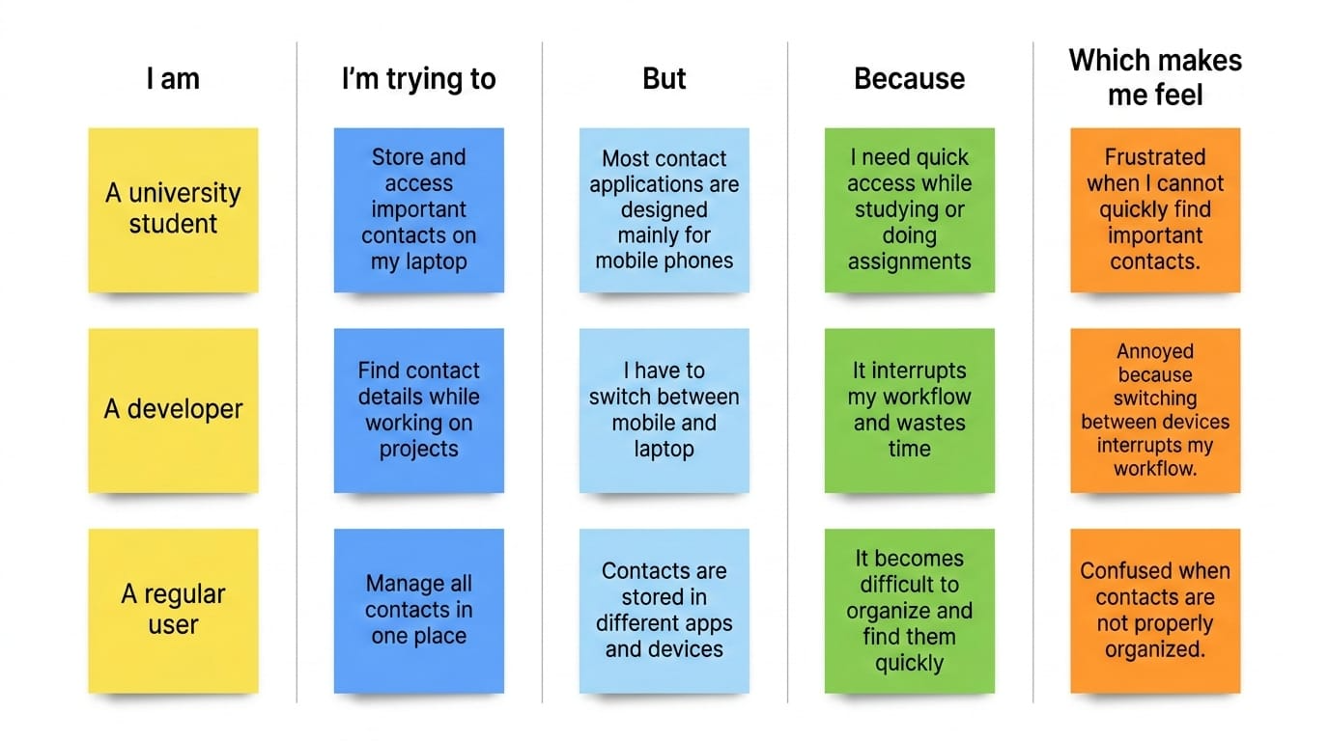
Problem Statement (PS) | I am (Customer) | I’m trying to | But | Because | Which makes me feel
PS-1 | A university student | Store and access important contacts on my laptop | Most contact applications are designed mainly for mobile phones | I need quick access while studying or doing assignments | Frustrated when I cannot quickly find important contacts
PS-2 | A developer | Find contact details while working on projects | I have to switch between mobile and laptop | It interrupts my workflow and wastes time | Annoyed because switching between devices interrupts my workflow
PS-3 | A Regular User | Manage all contacts in one place | Contacts are stored in different apps and devices | It becomes difficult to organize and find them quickly | Confused when contacts are not properly organized

